20 channel Lighting Controller

Introduction
This controller is designed to independently control 20 switched circuits. The board has an input for an Infra-Red receiver, (IR unit). The remote-control handset is used to control which circuits are turned on or off.
Each switched circuit can handle a load of 1 Amp. Most model Grain-of-Wheat (GOW), bulbs are rated at 60mA, (1000mA = 1Amp), so each of the 20 switched circuits could control 16 bulbs. Max board rating of 3Amps total should not be exceeded.
Each circuit is short circuit and overload protected. If a circuit is shorted out by a wiring fault, short circuit bulb or a faulty fitting, the system should be switched off and the fault located as soon as possible.

Installation & Power Supply
The unit must only be powered by a 12V power supply that is fitted with a standard 2.1mm connector. This type of connector is the standard type fitted to all the power supplies sold by us. If you have a power supply that is not fitted with a 2.1mm connector, we can supply a conversion kit.
Mount the board, using the mounting holes, in a well-ventilated location on an insulated surface. Plug in the Remote Control Infra-Red pickup cable and position the sensor on the end of the cable on your model in a position where it can receive the signal from the handset. The Chimmney of your model is a good spot.

Using the Remote Control Hand Set
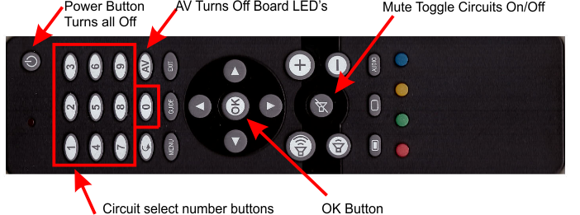
NOTE: - Not all buttons on the supplied hand set are being used.

To turn a channel On or Off enter the channel number and then press the OK button.
Example:
Turn circuit 2 On enter button 2 and then OK
Turn circuit 2 Off enter button 2 and then OK
Turn circuit 20 on/off enter buttons 2 then 0, (20), and then OK.
The Mute button “toggles” all channels, so all lights that are ON will be OFF. Any that are OFF will turn ON. The Mute button can be used when the power is first applied, to turn on every circuit so you can check that all the circuits and your lights are working. There is a small built in delay when switching on multiple circuits, this is to reduce power surges on the power supply that could blow the fuse.
The “AV” button will only turn off the LED indicators on the board. The controlled circuits will remain on or off as you selected. The AV button is provided if your board is mounted in a position where the Green glow from the LED’s detracts from your models appearance the “AV” button allows the board to be kept dark while the switched circuits can still be controlled.
The “Power” button will turn all channels Off.
IMPORTANT: It does not remove the board’s power. If you are leaving your model for any length of time turn the power off at the wall socket.
Before wiring to the models’ lights, apply power to the board and observe the Red LED11 (next to IC1), on each board blinks 5 times. The Red LED will go off after 5 blinks. This shows that the power supply is OK, and the boards are powered and working. Remove the power before wiring the models’ lights to the boards’ terminal strip.
The channels are numbered 1-20 on each board. Wire the lights to the screw terminal connectors in an order that makes sense to you. One terminal is the supply, +12V, while the second terminal is the switched circuit to 0V.
You can connect as many lights into a pair of terminals up to a maximum load of 1 amp refer to the Technical specification at the end of the document for more detail.
If you are connecting more than one light into a pair of terminals, the multiple lights should be wired in parallel.
You may want to do this, if say, you are switching wall lights and you want them all to be controlled from one circuit. To do this each individual wire from each light should be twisted together with the next light. The second wire is likewise twisted together before inserting into the terminal block. Make sure that the wires going into terminals do not short out, even a tiny strand of wire can do this!
NOTE: - If you are using LED lights you will need to fit a resistor in series with each LED light (if it is not incorporated into the fitting), follow the supplier’s recommendation for the resistor value. Polarity is important for LED lights, the Positive wire should go to the +12V terminal and the other one to the switched 0V terminal of the board.

Fault finding
Fault | Diagnosis
No circuits working | Remote control signal not reaching IR detector Power not on at the wall socket  12V supply not working  12V supply overloaded  Board Fuse failed – replace with same size fuse
Green LED is on but light fitting is not on – other circuits are working | Open circuit wiring  Screw terminal clamping on wire insulation  Screw terminal not gripping wire  Bulb in the light fitting has failed
Green LED is not on and circuit is not working – other circuits are working | Circuit wiring or Bulb is short circuit – Turn off to prevent overheating the board!
Red LED remains ON | Remote IR detector has not been found. Check that the IR detector is plugged in on the Master board.  Replace IR detector if the cable, plug or detector has become damaged.

Technical Specification
Max Supply Voltage: 12 Volts DC only
Min Supply Voltage: 9 Volts DC only
Fuse Sizes: 3.0 Amp is fitted as standard change the fuse to match your Power Supply the following table is a guide.
Our Part No | Power Supply Capacity | Fuse Size | 30mA Bulbs | 60mA Bulbs
RSL006 | 0.5 Amp 500mA | 500mA Slow Blow | 16 | 8
RSL005 | 2.0 Amp | 1.0 Amp Slow Blow | 65 | 32
RSL004 | 3.0 Amp | 2.5 Amp Slow Blow | 100 | 50
RSL003 | 5.0 Amp | 3.0 Amp Slow Blow | 165 | 80

Maximum Board Capacity: 3 Amps
Control: Each of the 10 circuits can switch up to 1 Amp but Max Board capacity of 3 Amps must not be exceeded.
Short Circuit Conditions: Circuits are short circuit and overload protected with thermal shutdown.

